DATA HANDLING AND VISUALIZATION USING R
Course Code: DSA0601
SET 3: EMPLOYEE PERFORMANCE EVALUATION
DATASET: EMPLOYEE PERFORMANCE
Employee ID | Department | Years of Service | Performance Score
1 | Sales | 5 | 85
2 | HR | 3 | 92
3 | Marketing | 7 | 78
4 | Sales | 4 | 90
5 | HR | 2 | 76

PROGRAM 1: LINE CHART
Aim
To create a line chart to visualize the performance trend of employees.
Dataset
Employee ID and Performance Score from the Employee Performance dataset.
R Code
# Employee Performance Dataset

employee_id <- c(1, 2, 3, 4, 5)
performance_score <- c(85, 92, 78, 90, 76)

# Create Line Chart
plot(employee_id,
performance_score,
type = "o",
xlab = "Employee ID",
ylab = "Performance Score",
main = "Employee Performance Trend",
col = "blue",
pch = 19)

# Add Legend
legend("topright",
legend = "Performance Score",
col = "blue",
lty = 1,
pch = 19)
Explanation
- employee_id stores the employee IDs.
- performance_score stores the performance scores.
- plot() creates the line chart.
- type = "o" displays both points and connecting lines.
- xlab gives the X-axis label.
- ylab gives the Y-axis label.
- main gives the chart title.
- legend() adds the legend.
Output
A line chart with:
- X-axis: Employee ID
- Y-axis: Performance Score
- Title: Employee Performance Trend
- Legend: Performance Score
The performance values are:
- Employee 1 → 85
- Employee 2 → 92
- Employee 3 → 78
- Employee 4 → 90
- Employee 5 → 76
Observation / Inference
The performance scores vary among the employees. Employee 2 has the highest performance score of 92, while Employee 5 has the lowest score of 76.
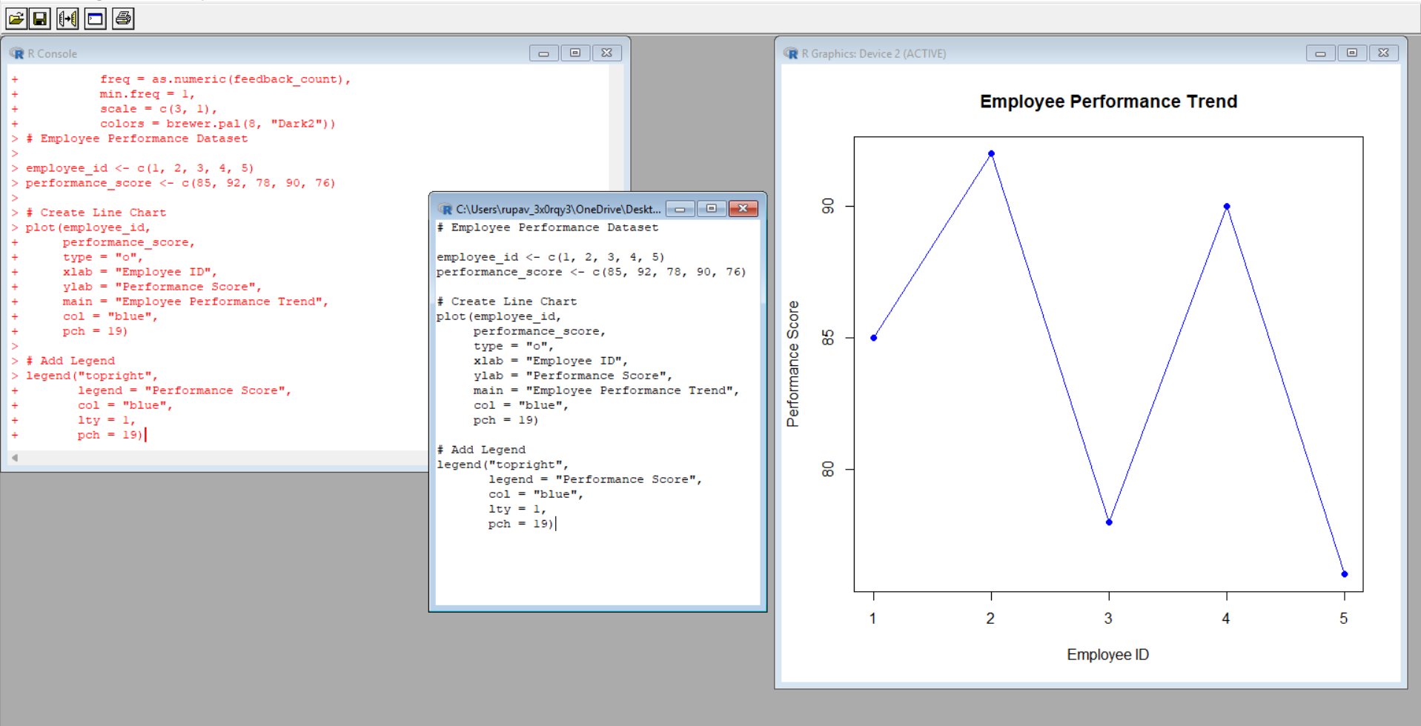
Result
The employee performance trend was successfully visualized using a line chart.
Key R Functions Used
plot(), legend()

PROGRAM 2: BAR CHART
Aim
To generate a bar chart showing the distribution of employees across different departments.
Dataset
Department information from the Employee Performance dataset.
R Code
# Employee Department Dataset

department <- c("Sales", "HR", "Marketing", "Sales", "HR")

# Count employees in each department
department_count <- table(department)

# Create Bar Chart
barplot(department_count,
names.arg = names(department_count),
xlab = "Department",
ylab = "Number of Employees",
main = "Employee Distribution by Department",
col = c("skyblue", "lightgreen", "orange"))

# Add values above bars
text(x = seq_along(department_count),
y = department_count,
labels = department_count,
pos = 3)
Explanation
- department stores the department names.
- table() counts the number of employees in each department.
- barplot() creates the bar chart.
- names.arg displays department names.
- xlab and ylab provide axis labels.
- main provides the chart title.
- text() displays the employee count above each bar.
The department counts are:
Department | Number of Employees
Sales | 2
HR | 2
Marketing | 1
Output
A bar chart showing:
- Sales → 2 employees
- HR → 2 employees
- Marketing → 1 employee
Observation / Inference
Sales and HR have 2 employees each, while Marketing has 1 employee.
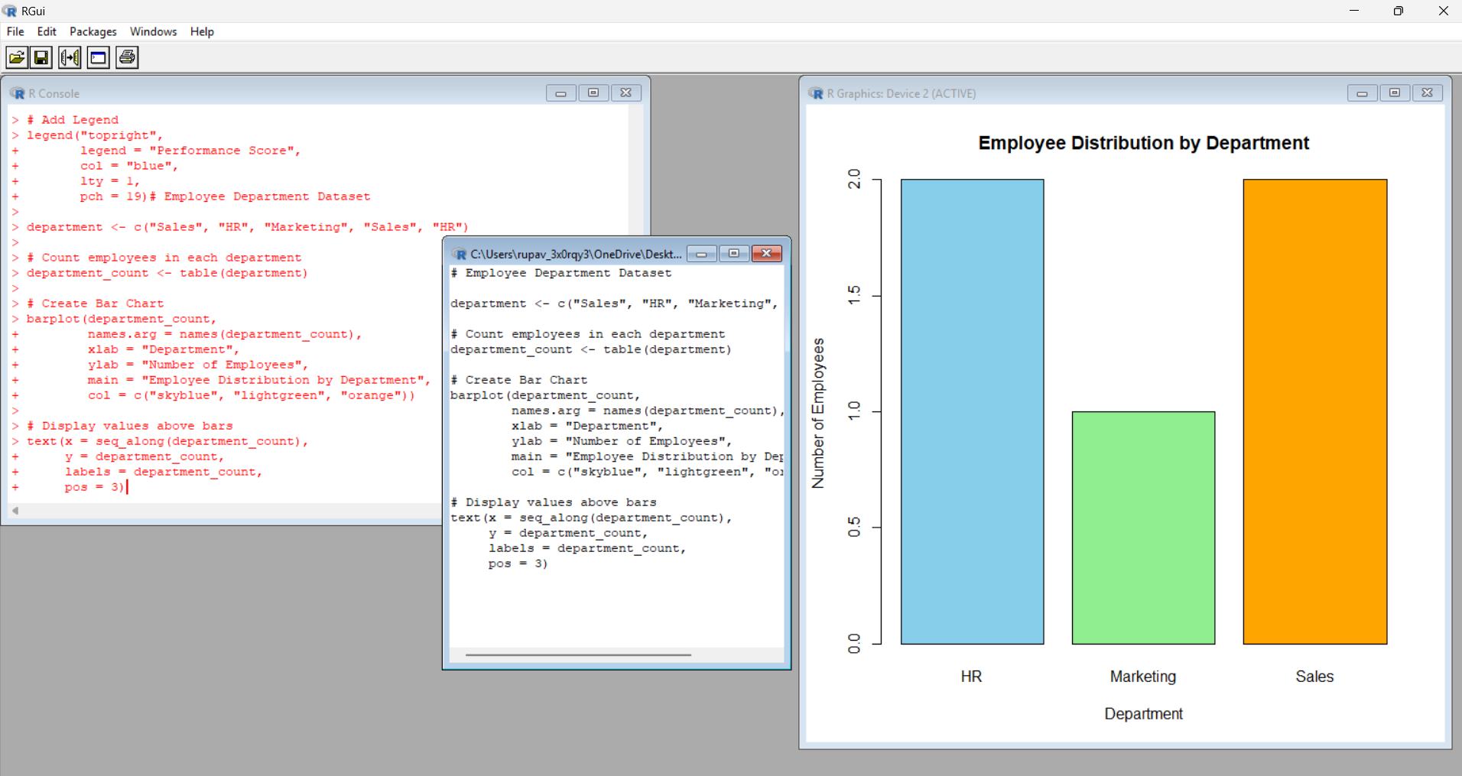
Result
The distribution of employees across departments was successfully represented using a bar chart.
Key R Functions Used
table(), barplot(), text()

PROGRAM 3: SCATTER PLOT
Aim
To analyze the correlation between years of service and performance scores using a scatter plot.
Dataset
Years of Service and Performance Score from the Employee Performance dataset.
R Code
# Employee Performance Dataset

years_service <- c(5, 3, 7, 4, 2)
performance_score <- c(85, 92, 78, 90, 76)

# Create Scatter Plot
plot(years_service,
performance_score,
main = "Years of Service vs Performance Score",
xlab = "Years of Service",
ylab = "Performance Score",
pch = 19,
col = "blue")

# Calculate linear model
model <- lm(performance_score ~ years_service)

# Add Trend Line
abline(model,
col = "red",
lwd = 2)
Explanation
- years_service contains the years of service of employees.
- performance_score contains their performance scores.
- plot() creates the scatter plot.
- lm() calculates a simple linear model.
- abline() adds the trend line to the scatter plot.
Expected Output
A scatter plot with:
- X-axis: Years of Service
- Y-axis: Performance Score
- A trend line showing the general relationship.
The five observations are:
(5, 85)
(3, 92)
(7, 78)
(4, 90)
(2, 76)
Observation / Inference
For these five observations, the relationship appears negative, because the fitted trend line slopes downward.
However, this is only an observed correlation in this small dataset. Correlation does not establish causation.
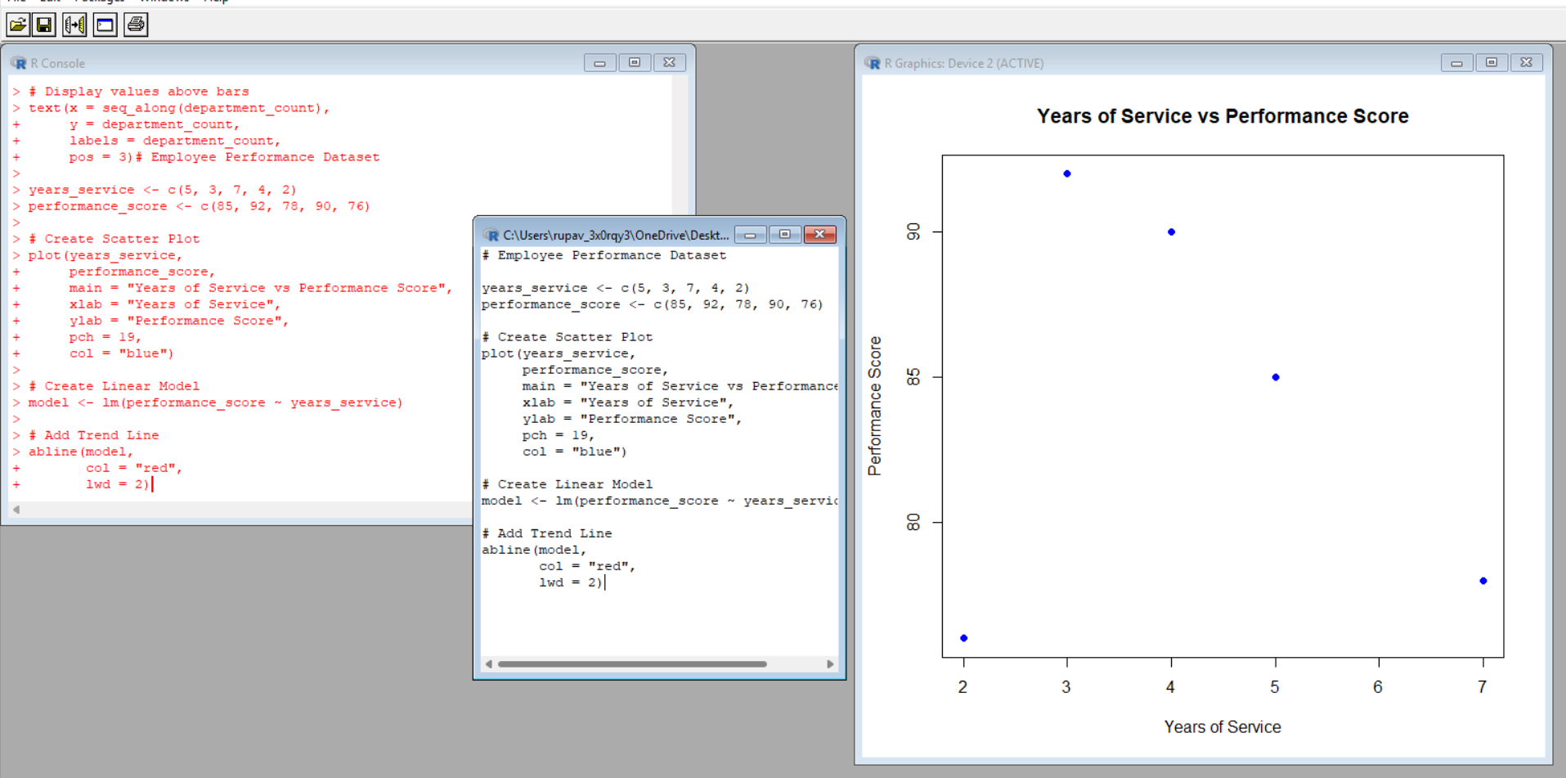
Result
The relationship between years of service and performance score was successfully analyzed using a scatter plot and trend line.
Key R Functions Used
plot(), lm(), abline()

PROGRAM 4: TABLEAU DASHBOARD
Aim
To develop a Tableau dashboard containing the line chart and bar chart for interactive exploration.
Important Note
Tableau is separate from R. No R code is required for creating the Tableau dashboard.

Step 1: Prepare the Dataset
Create an Excel file named:
Employee_Performance.xlsx
Enter the following data:
Employee ID | Department | Years of Service | Performance Score
1 | Sales | 5 | 85
2 | HR | 3 | 92
3 | Marketing | 7 | 78
4 | Sales | 4 | 90
5 | HR | 2 | 76

Step 2: Import Dataset into Tableau
- Open Tableau Desktop or Tableau Public.
- Select Microsoft Excel under Connect.
- Select Employee_Performance.xlsx.
- Tableau will display the dataset.
- Open a new worksheet.

Step 3: Create Line Chart
Create a worksheet named:
Employee Performance Trend
Drag the fields as follows:
Columns → Employee ID
Rows → Performance Score
Then:
- Select Line from the Marks card.
- Add Employee ID to Label if required.
- Set the chart title as Employee Performance Trend.
The chart shows the performance score of each employee according to Employee ID.

Step 4: Create Department Bar Chart
Create another worksheet named:
Employee Department Distribution
Drag the fields:
Columns → Department
Rows → Employee ID
Change the Employee ID aggregation to:
COUNT(Employee ID)
Then:
- Select Bar from the Marks card.
- Select Show Mark Labels.
- Set the chart title as Employee Distribution by Department.
The chart will show:
Sales → 2
HR → 2
Marketing → 1

Step 5: Create Dashboard
- Click New Dashboard.
- Name the dashboard:
Employee Performance Dashboard
- Drag Employee Performance Trend onto the dashboard.
- Drag Employee Department Distribution onto the dashboard.
- Arrange the two charts properly.
- Adjust their sizes.

Step 6: Add Filter / Interactivity
To add a department filter:
- Select the Department field.
- Add it to the Filters area.
- Select Show Filter.
- The user can select:
All
Sales
HR
Marketing
This allows the user to interactively explore the employee information.

PROCEDURE
- Open R/RStudio.
- Enter the Employee Performance dataset.
- Execute Program 1.
- Observe the generated line chart.
- Execute Program 2.
- Observe the generated bar chart.
- Execute Program 3.
- Observe the scatter plot and trend line.
- Prepare the same dataset in Excel for Tableau.
- Import the dataset into Tableau.
- Create the required line chart worksheet.
- Create the department bar chart worksheet.
- Combine both worksheets into one dashboard.
- Add filters/interactivity.
- Observe the final Tableau dashboard.

FINAL RESULT
Thus, the Employee Performance dataset was successfully analyzed using line, bar, and scatter plots in R. The relationship between years of service and performance score was examined, and an interactive Tableau dashboard containing the line chart and department bar chart was developed.

